#To create release branch

git flow release start <sprint1-release>

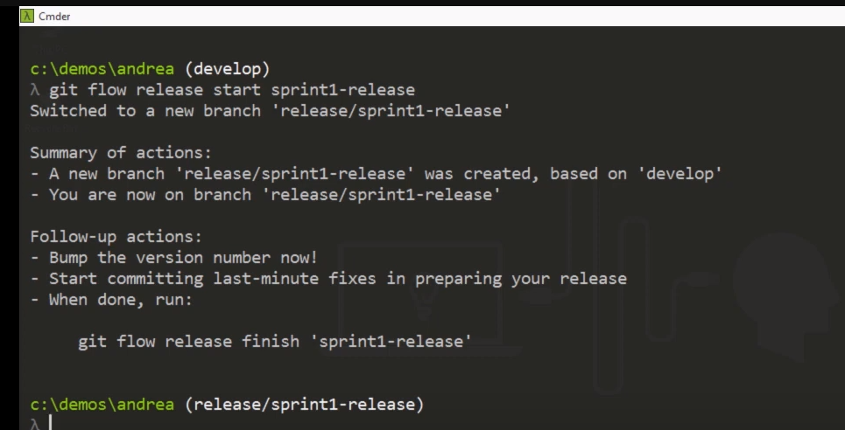

#To share the release branch with teams

git flow release publish sprint1-release

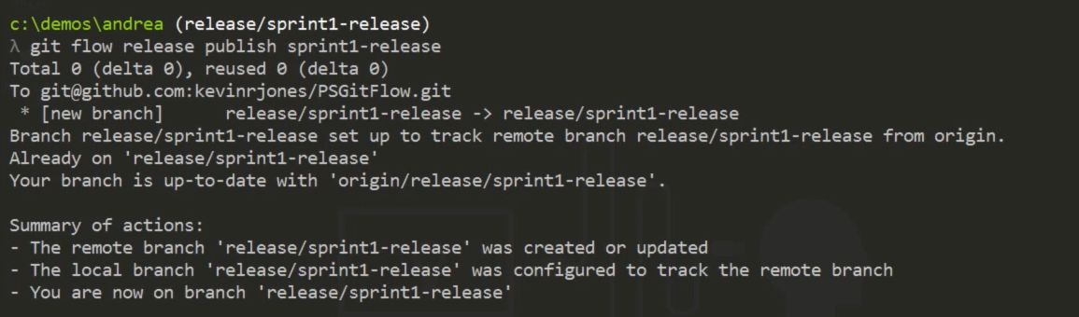

#To track the release branch

git flow release track sprint1-release

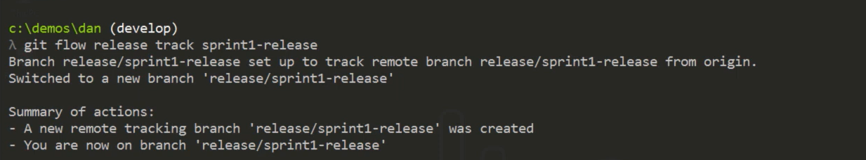

#Make changes to release branch and push the changes

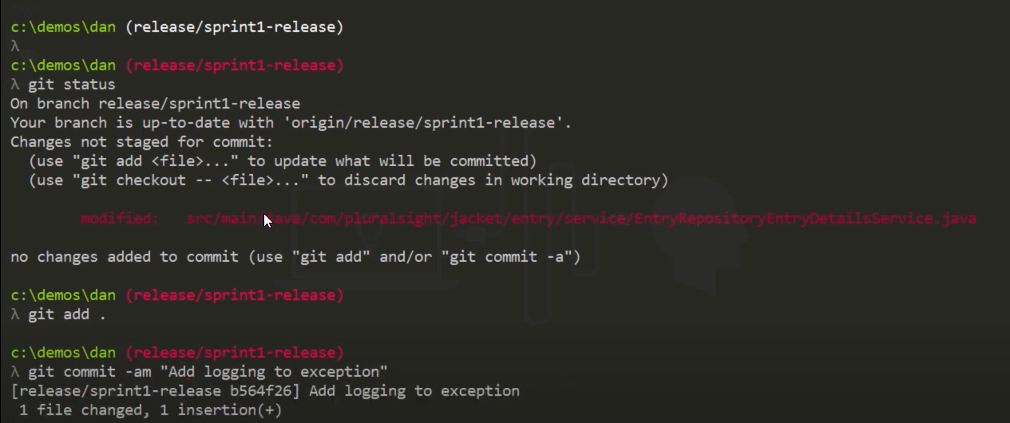

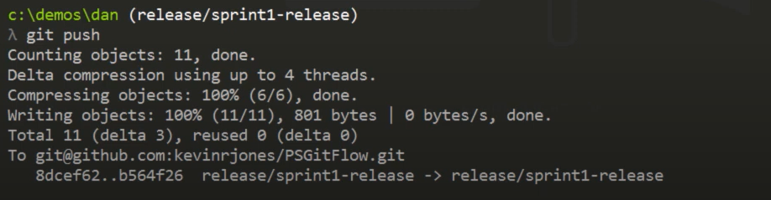

#To merge the any fixes in release branch to develop branch

git checkout develop

git pull

git merge release/sprint1-release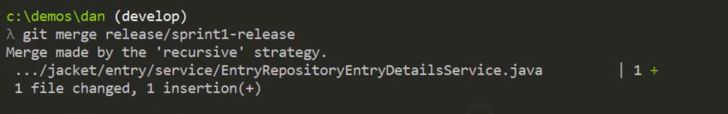

#Finally to finish the release activity, release branch will be merged to master (Below command does couple of things, it merge our changes to master branch )

git flow release finish sprint1-release

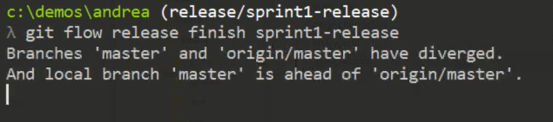

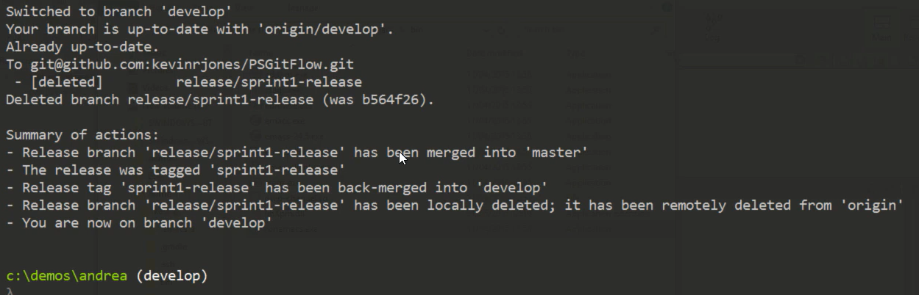

#finally push the tag

Git push --tags

